Complete Guide to Anniversary and Wedding Gifting with Mematgo
Celebrations that mark love, commitment, and togetherness deserve to be honored with meaningful gifts. Whether it is a wedding anniversary or a marriage celebration, gifting plays a vital role in expressing emotions that words often cannot fully convey. Carefully selected anniversary and wedding gifts symbolize appreciation, gratitude, and long-lasting bonds. In today’s evolving gifting culture, personalization and thoughtful curation have become essential elements of memorable celebrations.
This comprehensive guide explores how anniversary gifts and wedding gifts can be chosen thoughtfully for different relationships, life stages, and emotional contexts. From spouses and parents to friends and couples, the right gift creates lasting impressions and cherished memories.
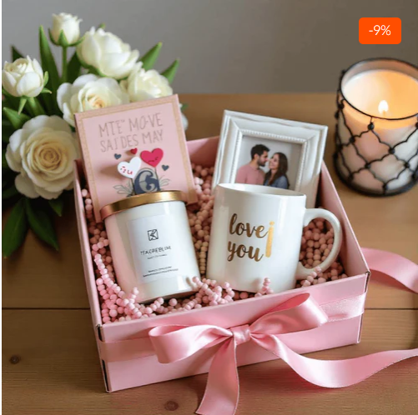

Understanding the Importance of Anniversary Gifts
Anniversaries celebrate milestones in a relationship. Each year reflects shared experiences, challenges, and growth. Anniversary gifts are not merely material offerings; they are emotional tokens that recognize commitment and love built over time.
Modern gifting trends emphasize meaning over price. Thoughtful anniversary gifts are selected based on emotional relevance, personalization, and daily usability. When gifts resonate with personal memories, they strengthen emotional bonds and deepen relationships.

Anniversary Gift for Husband: Thoughtful and Meaningful Choices
An anniversary gift for husband should reflect appreciation, admiration, and companionship. Practical yet personalized gifts are often preferred, as they seamlessly blend daily use with emotional value. Items customized with names, initials, or heartfelt messages are perceived as more meaningful and memorable.
Personalized accessories, lifestyle products, and keepsakes are commonly chosen because they align with both sentiment and practicality. Such gifts ensure that emotional connection is reinforced every day, not just on the anniversary date.

Anniversary Gift for Wife: Celebrating Love and Appreciation
An anniversary gift for wife is traditionally selected to express affection, gratitude, and emotional closeness. Thoughtfully curated gifts reflect understanding and effort. Personalization enhances the emotional impact and transforms simple products into cherished keepsakes.
Customized gifts with romantic messages or shared memories are particularly valued. They highlight the emotional journey shared by the couple and reinforce mutual appreciation.

Anniversary Gifts for Couples: Celebrating Togetherness
Anniversary gifts for couples are designed to celebrate unity and shared milestones. Such gifts focus on togetherness rather than individual preferences. Personalized couple-oriented products, home décor, and shared-use items are popular choices.
Couple gifts symbolize harmony and partnership. When thoughtfully curated, they enhance emotional connection and create shared experiences that couples can enjoy together.

Anniversary Gifts for Parents: Honoring Lifelong Commitment
Parents’ anniversaries represent enduring love and lifelong dedication. Anniversary gifts for parents should reflect respect, gratitude, and admiration. These gifts are often chosen to honor family values and shared memories.
Personalized keepsakes, elegant home décor, and utility-based products are preferred. Such gifts combine emotional significance with everyday relevance, making them ideal for long-term appreciation.

Wedding Anniversary Gifts: Marking Milestones with Meaning
Wedding anniversary gifts commemorate the foundation of marriage and the journey that follows. Each wedding anniversary holds unique significance, whether it is the first or the fiftieth. Gifts selected for these occasions should align with the milestone being celebrated.
Customized and thoughtfully curated gifts ensure that the emotional value of the occasion is preserved. They allow couples to relive memories while creating new ones.

Wedding Gifts: Celebrating New Beginnings
Weddings symbolize new beginnings and shared dreams. Wedding gifts are traditionally given to support and celebrate the couple’s new journey together. Modern wedding gifting emphasizes personalization, practicality, and long-term usefulness.
Thoughtful wedding gifts reflect genuine care and consideration. They are selected to complement the couple’s lifestyle and preferences while offering emotional warmth.

Wedding Gifts for Couples: Practical and Personal
Wedding gifts for couples are chosen with shared use in mind. Home essentials, personalized décor, and couple-themed products are commonly preferred. Such gifts enhance the couple’s daily life and serve as constant reminders of their special day.
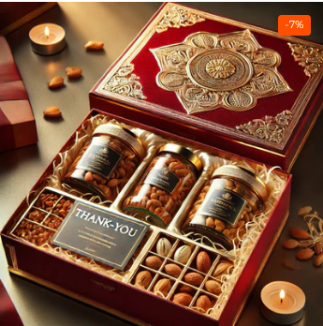
Personalized couple gifts strengthen emotional bonds by reflecting shared identity and partnership. They also hold sentimental value long after the wedding celebration has concluded.

Wedding Gift for Friend: Meaningful and Memorable Options
A wedding gift for friend should reflect closeness and understanding of personal taste. Friends often prefer gifting items that combine creativity, emotion, and usability. Personalized gifts are ideal because they showcase effort and thoughtfulness.
When selected carefully, wedding gifts for friends become lasting reminders of shared memories and meaningful relationships.

Wedding Gift for Best Friend: Celebrating a Special Bond
A wedding gift for best friend holds deeper emotional significance. Best friends share milestones, experiences, and memories that span years. Gifting on such occasions requires a personal and heartfelt approach.
Customized gifts that incorporate shared jokes, memories, or messages are particularly impactful. They celebrate not only the wedding but also the enduring friendship behind it.

Choosing Personalized Gifts for Anniversaries and Weddings
Personalization has transformed the gifting experience. Customized gifts are perceived as more thoughtful and emotionally valuable than generic alternatives. Names, dates, and personal messages elevate the significance of any gift.
Personalized gifts also demonstrate effort and intention. They reflect time spent understanding the recipient’s preferences, making the gift more meaningful.

Practicality and Emotional Balance in Gifting
The most appreciated gifts balance emotional appeal with practicality. Gifts that are used daily continue to evoke positive emotions long after the celebration ends. This balance ensures lasting relevance and satisfaction.
Utility-based gifts combined with personalization create a perfect blend of function and sentiment. Such gifts are suitable for both anniversaries and weddings.

Why Mematgo Is the Preferred Gifting Destination
Mematgo has established itself as a trusted platform for personalized gifting. With a wide range of customizable products and premium-quality materials, Mematgo caters to diverse gifting needs.
Customers are encouraged to buy customized gifts online from Mematgo with confidence. Each product is crafted with attention to detail, ensuring durability, aesthetics, and emotional value.

Quality, Craftsmanship, and Reliability
Quality assurance is a core focus at Mematgo. From material selection to final packaging, strict standards are maintained. Reliable delivery systems ensure that gifts reach customers on time, preserving the joy of celebrations.
Premium packaging enhances the overall gifting experience, making unboxing moments special and memorable.

Styling and Presentation of Anniversary and Wedding Gifts
Presentation plays a crucial role in gifting. Elegantly styled packaging elevates perceived value and emotional response. Thoughtful color schemes, textures, and layouts enhance the unboxing experience.
Mematgo emphasizes sophisticated presentation to ensure that gifts leave a lasting impression.

Long-Term Emotional Impact of Thoughtful Gifting
Thoughtful gifts create memories that last beyond the celebration. Personalized anniversary and wedding gifts continue to evoke emotions and appreciation over time. They become part of daily life and shared memories.
When gifting is approached with care and intention, it strengthens relationships and reinforces emotional connections.

Conclusion: Celebrate Love and Milestones with Meaningful Gifts
Anniversaries and weddings are milestones that deserve to be celebrated thoughtfully. Whether selecting anniversary gifts, wedding gifts for couples, or meaningful presents for friends and parents, personalization and emotional relevance are key.
With its commitment to quality, customization, and customer satisfaction, Mematgo simplifies the gifting journey. When emotions are expressed through carefully curated gifts, celebrations become truly unforgettable.

Thank You Mematgo Team

