Hindi Flypped News
Hindi Flypped Magazine – Your Complete Digital Magazine for Lifestyle, Travel, Sports & Bollywood
सोमवार शाम करीब 6:52 के करीब पर लाल किला मेट्रो स्टेशन (Red Fort Metro Station) के गेट नंबर 1 के पास एक सफेद Hyundai i20 कार अचानक विस्फोटित हुई। विस्फोट के तुरंत बाद आसपास कई कार आग की चपेट में आ गई।  इस घटना में अब तक 8 से 13 लोगों की मौतें और लगभग 20 से 30 घायल लोगों की संख्या को दर्ज किया गया हैं। दिल्ली पुलिस ने मामला दर्ज कर लिया है और जांच के लिए गैरकानूनी गतिविधियाँ (रोकथाम) अधिनियम (यूएपीए) Unlawful Activities (Prevention) Act (UAPA) एवं विस्फोटक कानून की धारा भी शामिल की गई है।  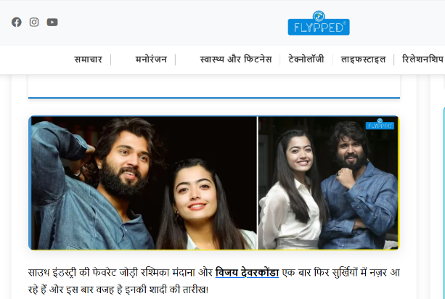  क्या Rashmika Mandanna and Vijay Deverakonda 26 फरवरी 2026 को शादी के बंधन में बंधने जा रहे हैं?  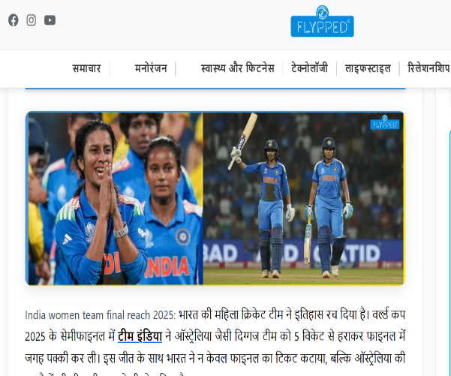  India women team final reach 2025: ऑस्ट्रेलिया को हराकर वर्ल्ड कप फाइनल में पहुँची टीम इंडिया! | 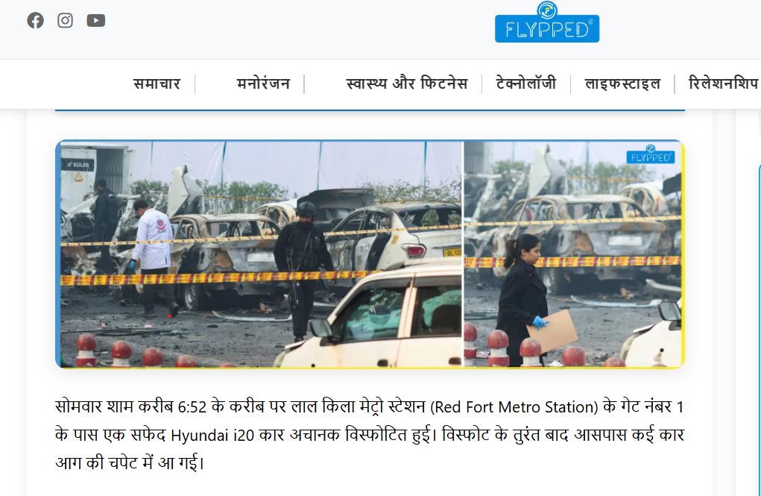  PICTURE CAPTION: Lorem ipsum dolor sit amet, consectetur adipiscing elit. Fusce vel laoreet orci. In eget auctor mi.  Delhi Blast: लाल किले के पास I20 Car में जबरदस्त Explosion, कई मौतें Terror Angle की जांच शुरू!
 | सोमवार शाम करीब 6:52 के करीब पर लाल किला मेट्रो स्टेशन (Red Fort Metro Station) के गेट नंबर 1 के पास एक सफेद Hyundai i20 कार अचानक विस्फोटित हुई। विस्फोट के तुरंत बाद आसपास कई कार आग की चपेट में आ गई।  इस घटना में अब तक 8 से 13 लोगों की मौतें और लगभग 20 से 30 घायल लोगों की संख्या को दर्ज किया गया हैं। दिल्ली पुलिस ने मामला दर्ज कर लिया है और जांच के लिए गैरकानूनी गतिविधियाँ (रोकथाम) अधिनियम (यूएपीए) Unlawful Activities (Prevention) Act (UAPA) एवं विस्फोटक कानून की धारा भी शामिल की गई है। | A sudden explosion in an i20 car near Delhi’s Rohini area on Wednesday evening caused panic among locals. The car was reportedly parked when the blast occurred, leading to smoke and minor fire damage. Police and forensic teams rushed to the spot to investigate the cause of the explosion. Early reports suggest it might have been triggered by a short circuit or gas leak, though official confirmation is still awaited. Fortunately, no casualties have been reported. Authorities have cordoned off the area and are examining CCTV footage to trace the sequence of events.
Latest Breaking news in hindi
KEYWORD  Hindi Flypped News – Your Daily Digital Magazine for Every Update |  | बिलासपुर में हादसे का ख़ौफ़नाक मंज़र, 11 की मौत और 20 घायल!  Get your daily dose of latest news updates India and today news updates only at Flypped News Portal.  Whether it’s a political shift, economic change, or global event, our editorial team ensures every reader gets the latest and most accurate news updates today.  Flypped keeps you connected to the pulse of the nation, providing real-time coverage and analysis to help you stay informed and engaged.  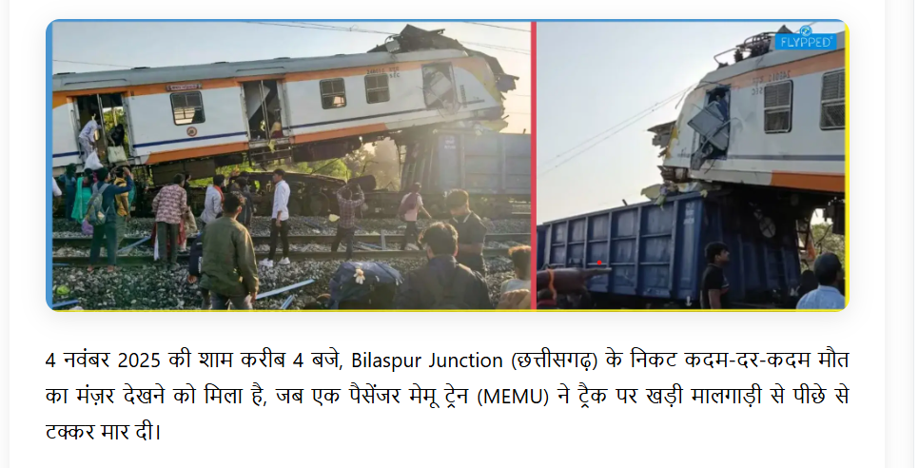  Agar aap khoj rahe hain ek reliable, fast aur engaging online Hindi magazine, toh Hindi Flypped News aapka perfect destination hai. Yahaan news hoti hai smart, stories hoti hain fresh, aur har headline ke peeche hoti hai sachchai ki kahani.  If you want to read in English, visit this Site: Flypped News Headlines  Bane rahiye connected Flypped Hindi News ke saath -  “Jahan har khabar likhi jaati hai dil se, aur padhi jaati hai desh bhar ke readers ke saath.”
fLYPPED eMAGAZINE  Flypped Hindi News is one of India’s fastest-growing digital magazines for lifestyle and news, bringing you the most reliable and trending stories in Hindi. From latest breaking news in Hindi to health, beauty, travel, and sports updates, we ensure every reader gets a complete daily dose of information — all in one place.  Our goal is to keep you connected with the pulse of India through short, factual, and engaging stories that reflect real voices, real issues, and real inspiration.  Stay informed with latest news updates in Hindi covering politics, economy, social trends, and entertainment.  We deliver the trending news today that matters — from national headlines to viral stories making waves on social media.  Flypped News Portal har topic ko simple Hinglish style mein present karta hai taaki har reader connect kar sake aur enjoy kare. Yahan aapko milta hai best Hindi magazine online experience jahan politics, Bollywood, technology, health aur women empowerment tak sab kuch ek click par available hai.  Agar aap khoj rahe hain ek reliable, informative aur entertaining online Hindi news magazine, toh Hindi Flypped News aapka perfect destination hai - jahan har khabar likhi jaati hai dil se aur padhi jaati hai pure desh ke readers ke saath. | 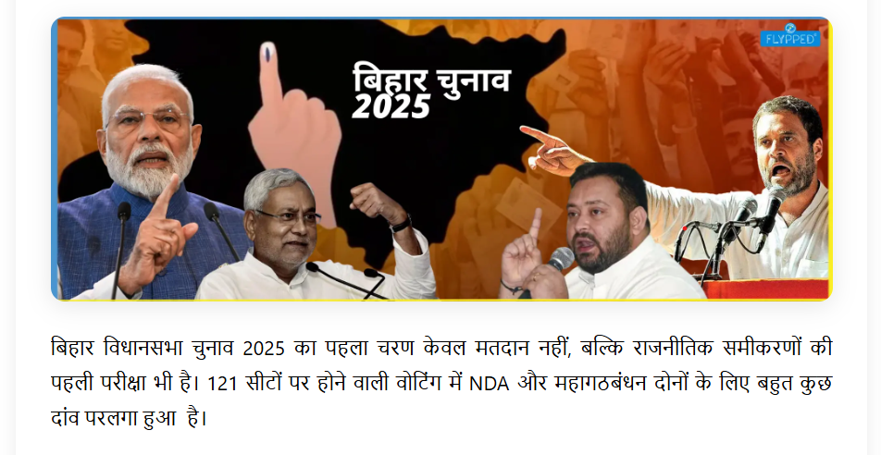  Bihar Election  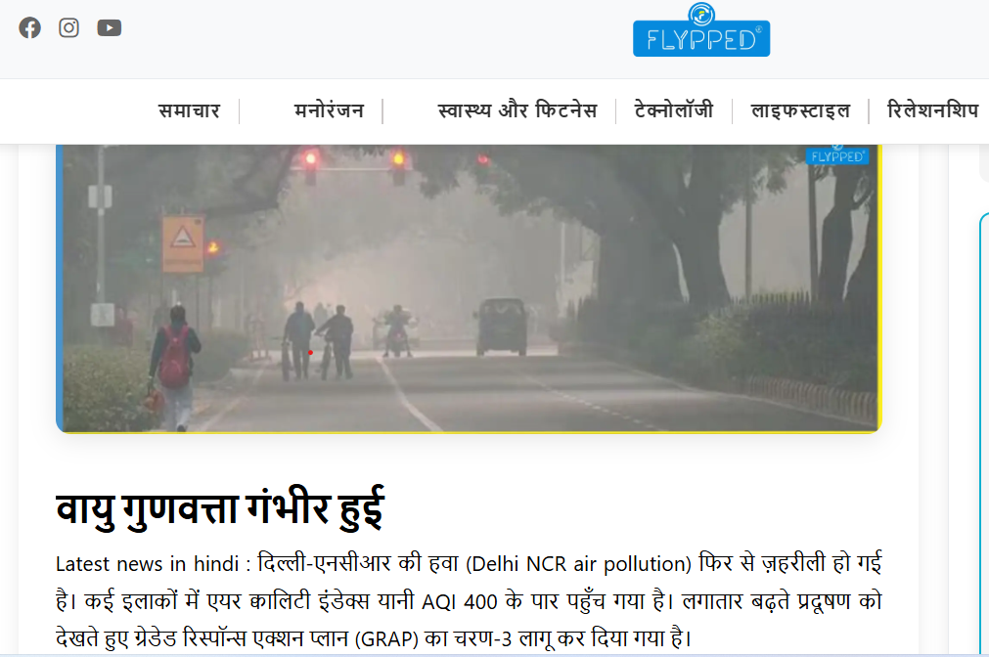  Fog or Pollution
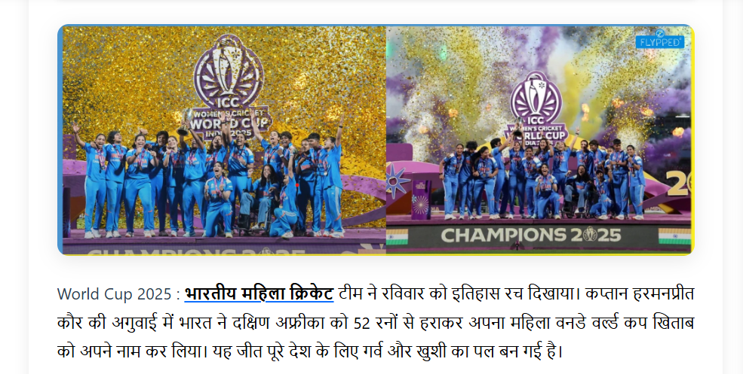

For all cricket lovers, our cricket news in Hindi section brings detailed match analysis, exclusive player interviews, and insights on the Indian Women’s Cricket Team and the Women’s World Cup.
We celebrate the spirit of Indian cricket — from the stadium to every home. Whether it’s the latest sports news or the biggest record-breaking chase, you’ll find it all here, explained in simple Hindi.

