Curated Valentines Gift Hamper for Husband to Impress This Valentine
Valentine’s Day is about expressing thoughtfulness, care, and love in a way that resonates deeply. A valentines gift hamper for husband provides a unique opportunity to combine meaningful personalization, practicality, and emotional connection into one thoughtful package. Carefully selected hampers reflect effort, creativity, and understanding, making your gift far more memorable than a single item.
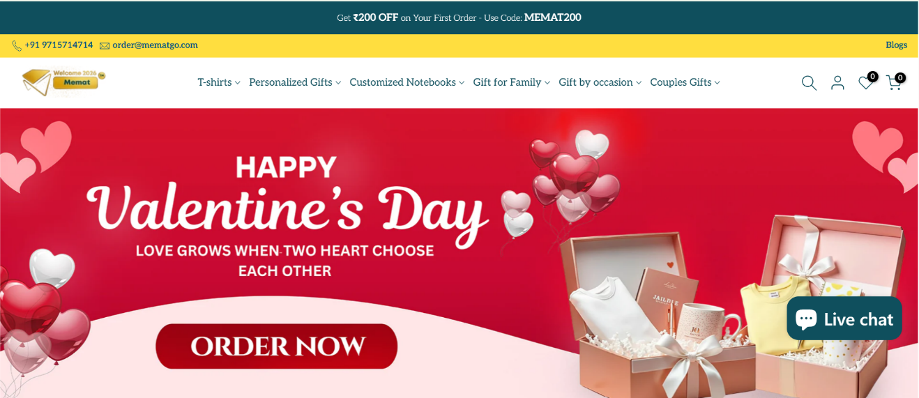
By including practical yet symbolic gifts like custom coffee mugs, a Valentine hamper transforms routine moments into emotional experiences that strengthen bonds over time.

Why Personalized Hampers Make a Stronger Impact
Generic gifts may feel pleasant initially but often fail to leave a lasting impression. Personalized hampers, on the other hand, show thought, attention, and effort, making the recipient feel truly appreciated.
Benefits of a valentines gift hamper for husband:
- Emotional depth beyond surface-level gifts
- Practicality combined with romance
- Long-term remembrance through everyday use
This multi-layered approach ensures your gift stands out and continues to create memories.

Integrating Daily-Use Items for Long-Term Relevance
Gifts that are used daily tend to reinforce emotional connections consistently. Incorporating practical items into a Valentine hamper ensures the gift remains relevant beyond the celebration day.
Morning rituals, in particular, are highly effective. By integrating gifts used in daily routines, you transform ordinary moments into reminders of love and care.

This Is Love Coffee: The Emotional Value of Custom Coffee Mugs
Coffee rituals are intimate, personal, and emotionally significant. Including custom coffee mugs in a Valentine hamper brings the “This Is Love Coffee” concept to life, creating moments that couples can enjoy together every morning.
Why custom coffee mugs enhance Valentine gifting:
- Blend functionality with emotional symbolism
- Reinforce daily connection and warmth
- Provide a subtle reminder of love without overwhelming
Unlike ornamental gifts, custom coffee mugs maintain relevance through repeated daily use, making them ideal for long-term emotional impact.
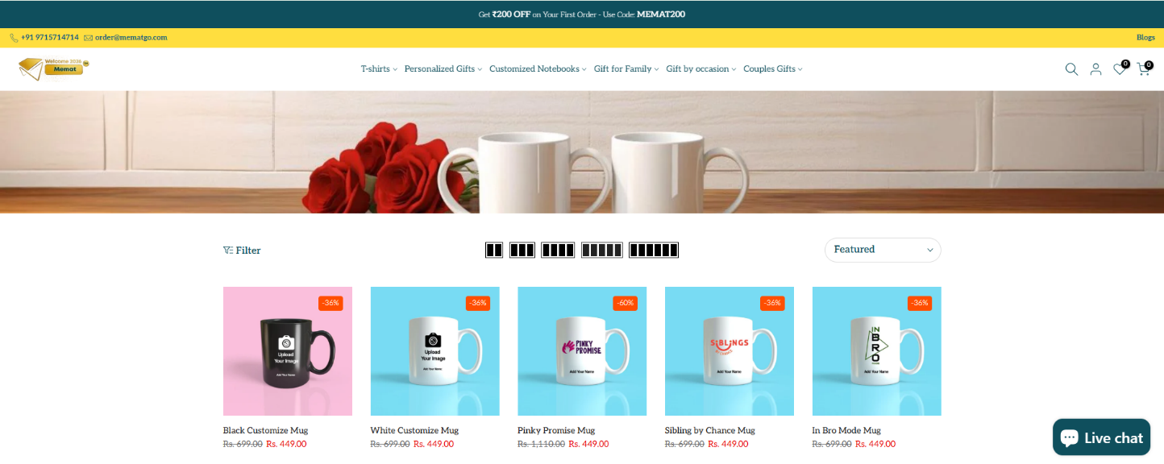

Product Section: Custom Coffee Mugs in Curated Hampers
Custom coffee mugs serve as the anchor of a Valentine hamper, symbolizing care while remaining practical.
Why these mugs work:
- Represent daily shared moments
- Offer personalized customization for emotional impact
- Complement other products in the hamper
Popular Product Variations Included:
- custom ceramic mugs – durable and elegant for daily coffee or tea
- personalized couple mugs – celebrating togetherness and shared identity
These carefully chosen items enhance the emotional and practical value of the hamper.

Balancing Emotional and Practical Gifts
The most successful Valentine hampers combine sentimentality with utility. While romantic keepsakes communicate love, practical gifts ensure continued relevance.
Effective balance includes:
- Emotional items such as handwritten notes or mementos
- Daily-use products like custom wallets for men
- Symbolic items like custom coffee mugs
This thoughtful mix makes the gift both heartfelt and functional.

The Importance of Thoughtful Personalization
Personalization goes beyond adding a name; it reflects understanding and attention to the recipient’s tastes. Personalized products in a hamper enhance emotional value and make the gift feel intentional.
Advantages of personalization:
- Creates stronger emotional connections
- Increases perceived thoughtfulness
- Enhances the unboxing experience

How Online Platforms Simplify Personalized Gifting
Online gifting platforms make it easy to customize hampers with precision. Buyers often buy customized gifts online from Mematgo, ensuring high-quality presentation and controlled personalization.
Benefits of online gift customization:
- Accurate and stress-free personalization
- Convenient shopping experience
- High-quality presentation for maximum impact
This allows thoughtful gifts to be delivered without logistical stress.

Mutual Gifting for Couples
Valentine’s Day increasingly celebrates shared experiences. While focusing on a husband hamper, couples may also curate a valentine gift hamper for wife to maintain balance and reciprocity in gifting.
Mutual gifting ensures:
- Emotional equality
- Shared enjoyment of personalized gifts
- Balanced celebration of love
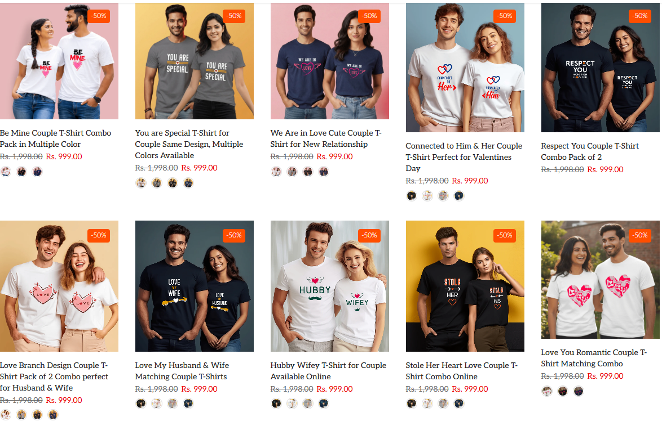

Why Hampers Deliver a More Complete Experience Than Single Gifts
Single gifts convey emotion in a limited way. Hampers, on the other hand, tell a story, combining multiple personalized elements with practical relevance.
Hampers succeed because:
- They provide multiple personalized touchpoints
- They integrate daily-use practicality
- They create a memorable unboxing experience
This makes them ideal for expressing long-term care and affection.

Future Valentine Gifting Trends
Emotional intelligence and practical usability will continue to dominate Valentine gifting trends. Products like custom coffee mugs transform everyday routines into moments of emotional connection.
Future gifting priorities:
- Emotional consistency
- Daily usability
- Thoughtful personalization
- Practical and symbolic balance
Curated hampers that integrate these elements will remain popular choices for couples seeking meaningful Valentine gifts.

Conclusion
A valentines gift hamper for husband combines love, practicality, and thoughtfulness in a way that single gifts rarely can. By including daily-use personalized items like custom coffee mugs and custom wallets for men, hampers create a memorable experience that continues to deliver emotional impact. Choosing a carefully curated hamper shows understanding, effort, and deep appreciation, making your Valentine’s Day gift truly unforgettable.

FAQs

1. Why include custom coffee mugs in Valentine hampers?
They transform daily coffee routines into moments that reinforce emotional connection.

2. How does personalization make Valentine hampers more meaningful?
It signals thoughtfulness and aligns the gift with the recipient’s personality and preferences.

3. Are online customized gifts reliable for Valentine hampers?
Yes, platforms like Mematgo ensure accurate personalization and high-quality presentation.

THANK YOU

