The Complete Guide to Meaningful Personalized & Custom Gifts
Gifting today is about emotional connection, not just exchange. Whether it’s a wedding, anniversary, or milestone celebration, personalized gifts add depth and thoughtfulness. From custom anniversary gifts to customized diary and pen, meaningful gifting transforms moments into memories.
Let’s explore the best personalized gifting options for every occasion.
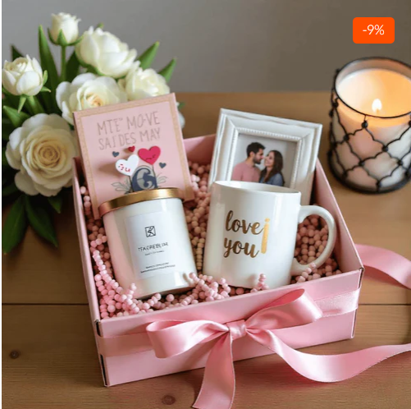

Anniversary Gifts – Celebrate Love That Lasts
Anniversaries are milestones of commitment, growth, and shared memories. Choosing custom anniversary gifts ensures your present reflects a couple’s journey.
Unlike ordinary presents, personalized anniversary gifts are curated around names, dates, shared quotes, or meaningful messages. They become keepsakes rather than temporary gifts.

Anniversary Gift for Husband – Practical Yet Emotional
Finding the right anniversary gift for husband requires balance — something sentimental yet useful.
Consider:
- Engraved accessories
- Customized keepsakes
- Personalized diaries
- Custom wallets
- Memory frames
A meaningful gift engraved with your anniversary date creates emotional depth. A personalized touch makes it unforgettable.

Anniversary Gift for Wife – Romantic & Elegant
An anniversary gift for wife should express love, appreciation, and admiration.
Thoughtful options include:
- Customized keepsake journals
- Personalized memory books
- Elegant accessories
- Handwritten message diaries
Romantic gestures become timeless when personalization is added.

Anniversary Gifts for Parents – Honoring Their Journey
Parents’ anniversaries celebrate decades of partnership. Choosing anniversary gifts for parents should focus on respect and gratitude.
A meaningful mom dad anniversary gift can include:
- Engraved keepsakes
- Personalized diary sets
- Photo memory collections
- Elegant gift hampers
Parents treasure gifts that reflect family appreciation.

Anniversary Gifts for Couples – Celebrate Togetherness
Looking for anniversary gifts for couples? Focus on unity and shared memories.
Personalized couple options:
- Matching accessories
- Engraved keepsakes
- Memory journals
- Coordinated gift sets
These gifts celebrate their shared story beautifully.

Wedding Gifts – Celebrate New Beginnings
Weddings mark the beginning of a new chapter. Choosing meaningful wedding gifts for couples ensures your gift stands out.
Generic gifts are forgotten. custom wedding gifts and personalized wedding gifts become lifelong memories.
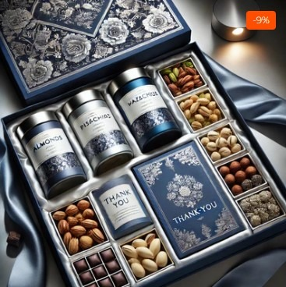

Best Wedding Gifts – Thoughtful & Unique
The best wedding gifts are:
- Emotional
- Practical
- Personalized
- Memorable
Personalization adds depth to your gifting gesture.

Wedding Gift for Bride – Elegant Choices
A meaningful wedding gift for bride should be stylish and sentimental.
Beautiful ideas:
- Customized journals
- Personalized keepsake boxes
- Elegant diary and pen combinations
Brides cherish gifts that preserve memories of their special day.

Wedding Gift for Best Friend – Make It Personal
Your best friend’s wedding is emotional. A wedding gift for best friend should reflect your bond.
Great options:
- Personalized couple keepsakes
- Engraved memory journals
- Customized celebration gifts
Personal touches make it unforgettable.

Wedding Gifts for Girls – Stylish & Meaningful
When selecting wedding gifts for girls, choose elegance with emotion.
Consider:
- Customized journals
- Personalized gift hampers
- Stylish keepsake accessories
Young brides appreciate thoughtful personalization.

Custom Wallet Collection – Practical Personalization
Men appreciate practical gifts with emotional value. custom wallets for men combine sophistication with personalization.
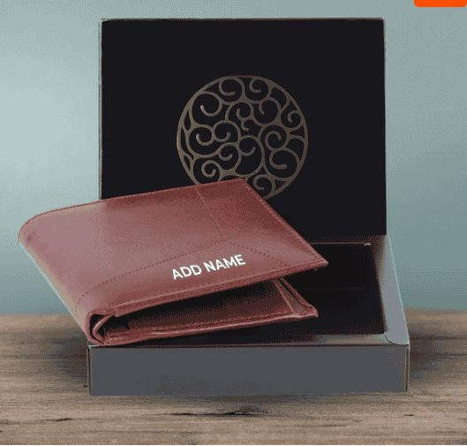

Wallet for Men with Name – Add Identity
A wallet for men with name adds exclusivity. Whether engraved with initials or a full name, it enhances everyday essentials.

Personalized Wallets for Men – Perfect for Every Occasion
personalized wallets for men are ideal for:
- Anniversaries
- Weddings
- Birthdays
- Corporate gifting
A customized wallet becomes both functional and sentimental.

Couple Gifts – Celebrate Love Together
custom couple Gifts symbolize unity and shared emotion. Matching items reflect connection.
Modern couples love personalized couple gifts that celebrate their journey.
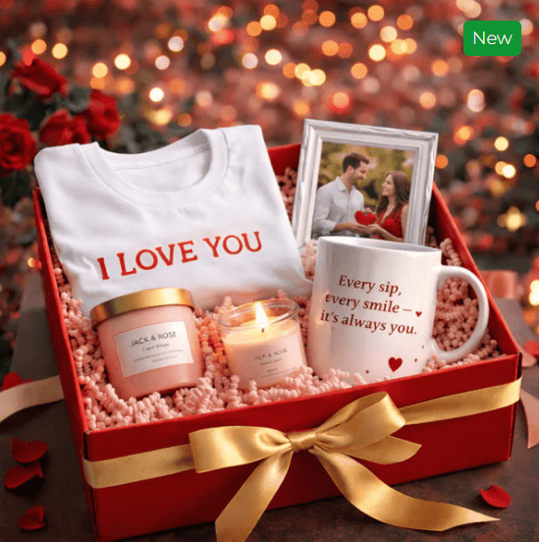
Popular ideas:
- Matching keepsakes
- Engraved accessories
- Coordinated gift sets
- Memory journals
These gifts strengthen emotional bonds.

Customized Diary Collection – Timeless & Elegant
In a digital world, handwritten notes still hold magic. A customized diary adds personality to everyday writing.

Customized Diary with Name – Personal & Unique
A customized diary with name transforms simple stationery into a personal statement.
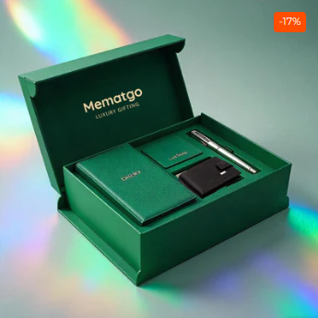
Perfect for:
- Students
- Professionals
- Writers
- Corporate gifting
Adding a name increases emotional value.

Customized Diary and Pen – Complete Gift Experience
A customized diary and pen offers sophistication and practicality.
Benefits include:
- Elegant presentation
- Professional appeal
- Suitable for milestone gifting
It is ideal for anniversaries, weddings, or promotions.

Diary and Pen Gift Set – Classic & Professional
A diary and pen gift set remains a timeless gifting choice.
Perfect for:
- Corporate events
- Wedding gifting
- Anniversary celebrations
- Graduation milestones
Classic elegance never goes out of style.

Personalised Diary and Pen Set – Premium Gifting Option
A personalised diary and pen set combines sentiment with utility.
It works beautifully as:
- Anniversary present
- Wedding keepsake
- Corporate appreciation gift
- Graduation gift
This combination ensures your gift is remembered long-term.

Why Personalized Gifting Wins Every Time
Personalization transforms ordinary gifts into lifelong memories.
From custom anniversary gifts to custom wedding gifts, from custom wallets for men to customized diary and pen, thoughtful customization creates deeper emotional connections.
Meaningful gifts:
- Strengthen relationships
- Show effort
- Create keepsakes
- Express emotion clearly

