Make Every Engagement Unforgettable with Personalized Gifting | MematGo

Introduction
An engagement marks the beginning of a lifelong journey between two individuals, filled with promises, dreams, and shared futures. It is not just a ceremony—it is an emotional milestone that deserves to be celebrated with thoughtfulness and meaning. In today’s modern gifting landscape, traditional presents are gradually being replaced by meaningful, tailor-made options that reflect emotions rather than just value.
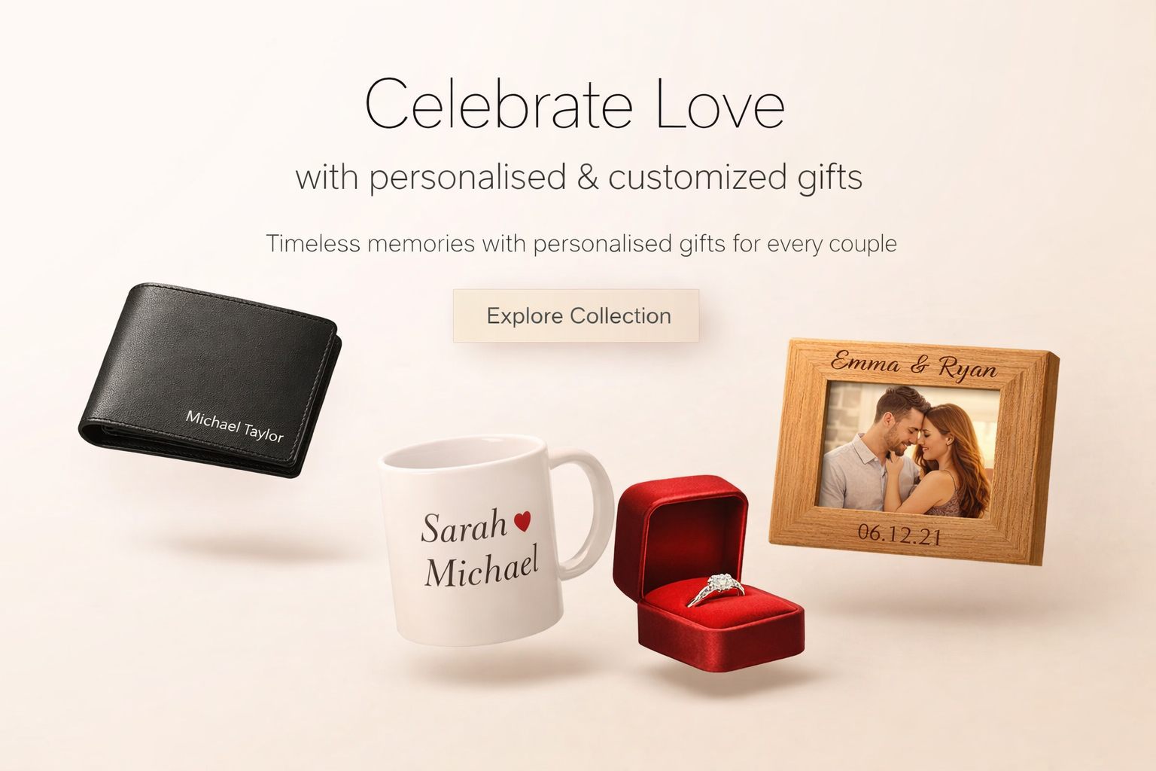
This is where personalisation steps in. Gifting is no longer about simply handing over an item; it’s about telling a story, capturing memories, and creating something that resonates deeply with the recipient. Whether it’s a custom keepsake, engraved memento, or memory-based gift, thoughtful gestures leave a lasting impression.
With the rise of personalised & customized gifts, people are now seeking ways to make their presents stand out—especially during engagements, where emotions run high and expectations are even higher. A well-chosen gift can become a cherished memory, symbolizing love and connection.
At MematGo, the philosophy revolves around transforming ordinary gifts into extraordinary experiences. By blending creativity with personalization, MematGo ensures that every gift carries a unique emotional value, making it truly unforgettable.

What Are personalised & customized gifts?
personalised & customized gifts are items that are specifically tailored to reflect an individual’s personality, relationship, or memory. Unlike generic products, these gifts are modified with names, dates, photos, or messages that hold sentimental value.
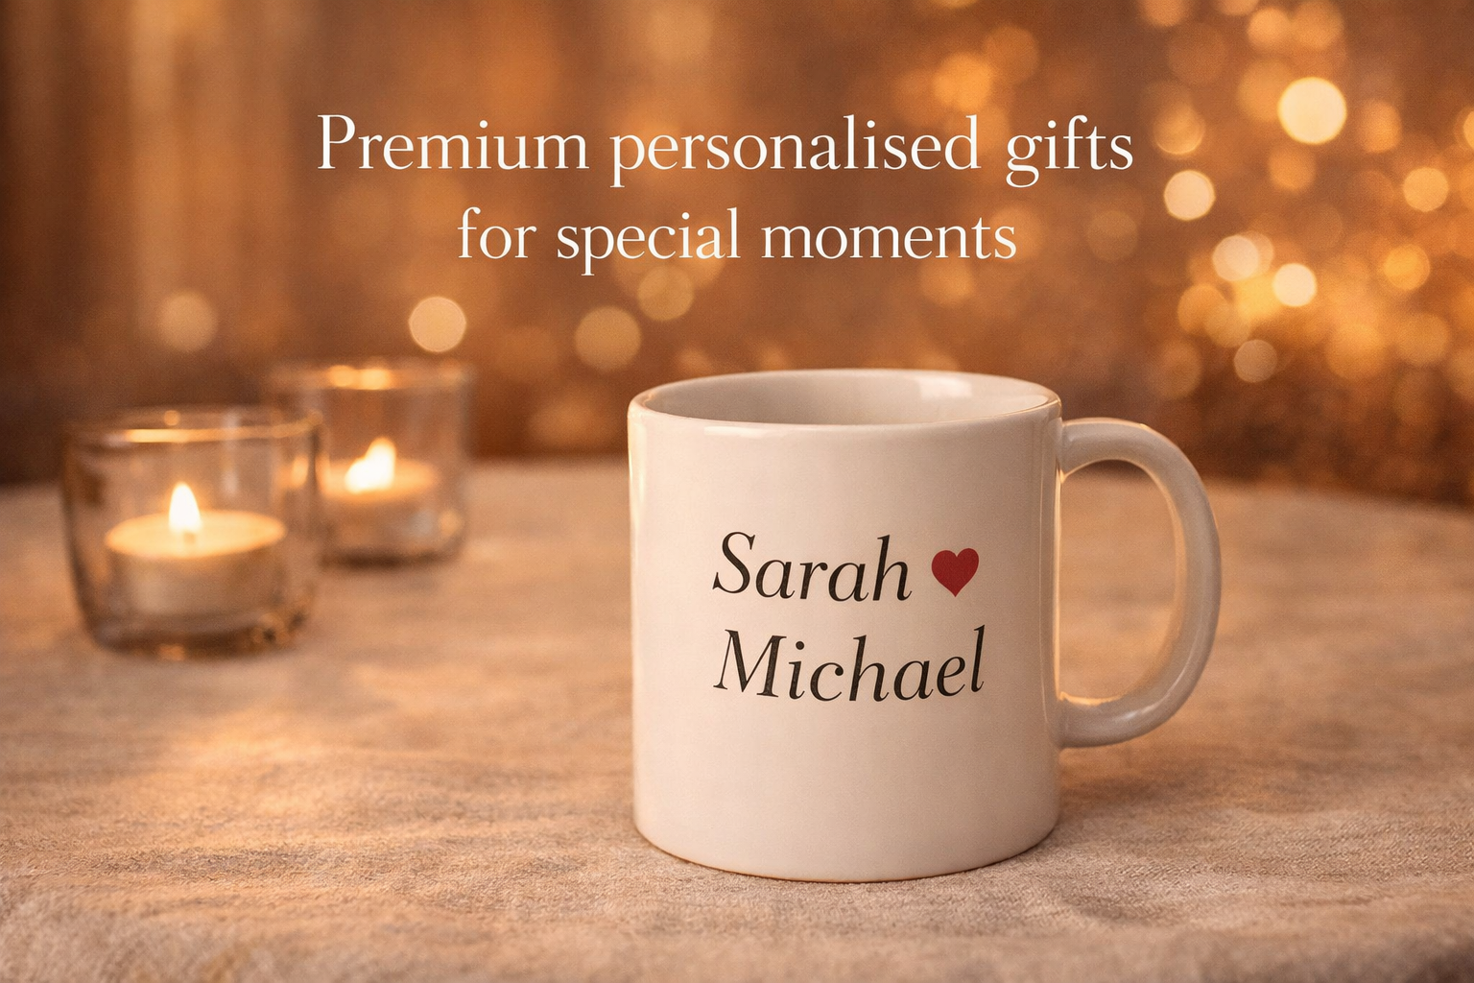

Key Characteristics:
- Tailor-made for the recipient
- Emotionally meaningful
- Unique and memorable
- Perfect for special occasions
These gifts go beyond aesthetics—they create emotional connections that last for years.

Why personalised gifts Are Trending
The surge in demand for personalised gifts is driven by a shift in consumer behavior. People now prioritize experiences and emotions over materialistic value.

Reasons Behind the Trend:
- Emotional Value – People want gifts that tell a story
- Uniqueness – No one wants to give or receive something generic
- Social Media Influence – Unique gifts are more shareable
- Stronger Connections – Personalized items strengthen relationships
Modern buyers are increasingly choosing meaningful gifting options that reflect thoughtfulness.

Importance of customized gifts in Modern Gifting
customized gifts have revolutionized how people express emotions. They allow individuals to create something deeply personal and specific.

Why They Matter:
- Reflect effort and thought
- Show deeper emotional investment
- Stand out among traditional gifts
- Create lasting impressions
In engagement scenarios, customization adds a layer of intimacy that generic gifts simply cannot match.

Complete Guide to engagement gifts
Choosing the right engagement gifts requires understanding the couple’s personality, preferences, and lifestyle.

Types of Engagement Gifts:
- Emotional keepsakes
- Practical items
- Decorative pieces
- Experience-based gifts
A perfect gift strikes a balance between utility and sentiment.

How to Choose the best engagement gifts
Selecting the best engagement gifts involves more than just budget—it requires insight and intention.
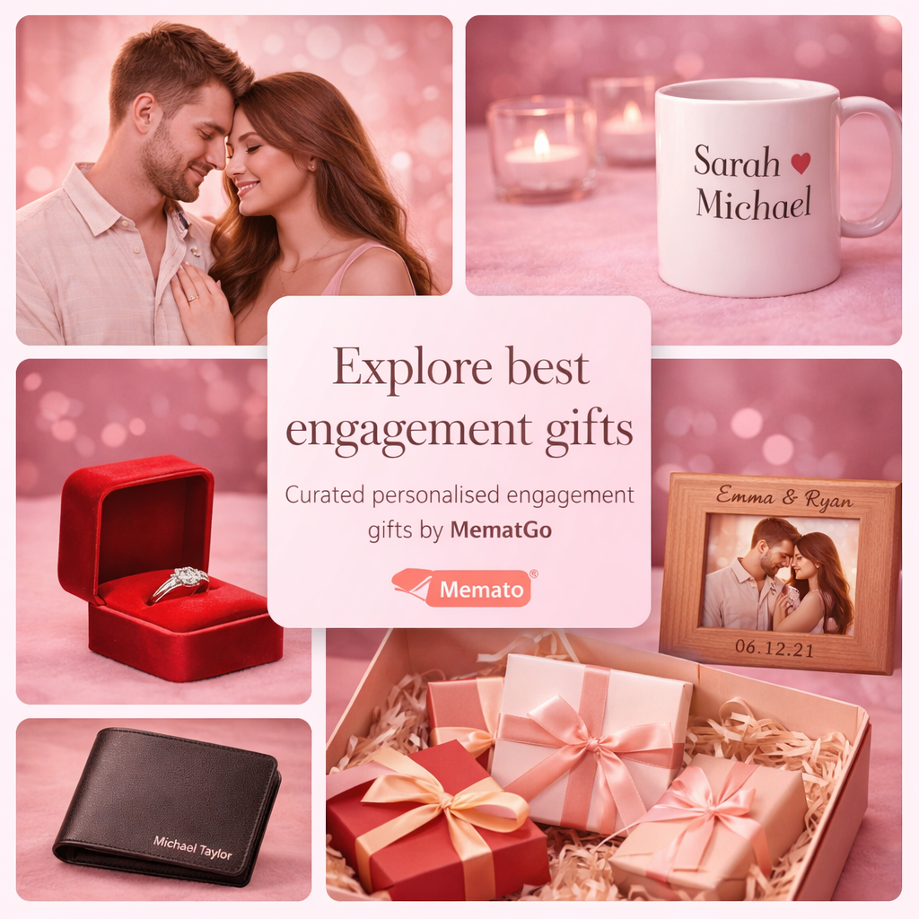

Step-by-Step Guide:
- Understand the couple’s taste
- Consider personalization options
- Focus on long-term usability
- Add emotional value
- Ensure quality
A thoughtful approach ensures your gift stands out and remains memorable.

Benefits of personalised engagement gifts
personalised engagement gifts offer unmatched emotional depth and uniqueness.

Key Benefits:
- Create lasting memories
- Strengthen emotional bonds
- Show genuine effort
- Make occasions more special
These gifts often become keepsakes that couples cherish forever.

Ideas for unique engagement gifts for couples
Finding unique engagement gifts for couples can be challenging but rewarding.

Creative Ideas:
- Customized photo frames
- Couple name art
- Memory scrapbooks
- Personalized home décor
These ideas help create gifts that feel truly one-of-a-kind.

Trending unique engagement gifts
The market for unique engagement gifts is constantly evolving with new creative concepts.

Trending Options:
- LED photo lamps
- Engraved wooden plaques
- Digital memory albums
- Customized couple caricatures
These modern options blend creativity with emotional storytelling.

Modern and cool engagement gifts for couples
Today’s generation prefers stylish and innovative options, making cool engagement gifts for couples highly popular.

Popular Choices:
- Personalized Spotify frames
- Custom neon signs
- Couple hoodies
- Travel memory kits
These gifts are trendy, functional, and visually appealing.

Practical engagement gifts for couples
While emotional gifts are important, practical engagement gifts for couples also hold great value.

Useful Gift Ideas:
- Customized kitchen sets
- Home décor items
- Personalized organizers
- Travel accessories
Combining practicality with personalization creates the perfect balance.
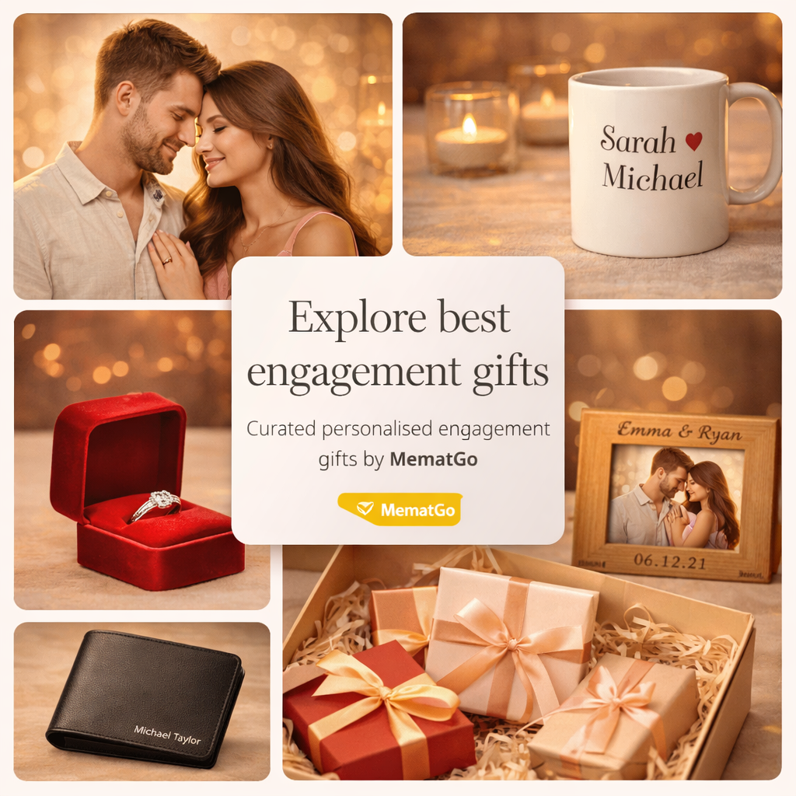

Detailed Gift Ideas Section (1000+ Words)
When it comes to engagement gifting, variety and creativity play a crucial role. A well-thought-out gift can transform a simple gesture into a lifelong memory.

1. Memory-Based Gifts
These gifts focus on capturing moments:
- Photo albums
- Timeline frames
- Story-based scrapbooks

2. Decorative Gifts
Perfect for enhancing home aesthetics:
- Wall art
- LED frames
- Nameplates

3. Functional Gifts
Useful in daily life:
- Kitchenware
- Organizers
- Travel kits

4. Luxury Personalized Gifts
For premium experiences:
- Engraved watches
- Customized jewelry
- Designer keepsakes

5. Experience Gifts
Create memories instead of objects:
- Travel vouchers
- Dinner experiences
- Adventure activities
At MematGo, each category is carefully curated to ensure quality, creativity, and emotional value.

Buying Guide Section
Choosing the perfect engagement gift requires strategic thinking.

Key Factors to Consider:
- Budget
- Personalization level
- Delivery time
- Quality of materials
- Brand reliability

Common Mistakes to Avoid:
- Choosing generic items
- Ignoring personalization
- Last-minute purchases
A planned approach ensures a meaningful gifting experience.

Why Choose MematGo
MematGo stands out as a trusted gifting brand that specializes in personalization and creativity.

What Makes MematGo Unique:
- High-quality materials
- Unique designs
- Wide product range
- Customization expertise
- Reliable delivery
MematGo focuses on turning emotions into tangible memories.

Customer Value & Emotional Connection
Gifting is deeply emotional. A well-chosen gift can strengthen relationships and create unforgettable memories.
MematGo understands this emotional aspect and ensures that every product reflects care, thought, and love.

Emotional Impact of Personalized Gifts:
- Strengthens relationships
- Creates lasting memories
- Enhances celebrations
- Builds deeper connections

Conclusion (Strong CTA)
Engagements are once-in-a-lifetime moments that deserve extraordinary celebration. Choosing the right gift is not just about the item—it’s about the emotion behind it. Personalized gifting offers a unique way to express love, appreciation, and joy.
With MematGo, you can transform your gifting experience into something truly unforgettable. From creative designs to meaningful personalization, every product is crafted to leave a lasting impression.
Don’t settle for ordinary—make your engagement gifts extraordinary with MematGo.

Contact Details
Phone: +91 9715714714
Email: order@mematgo.com
Website: https://www.mematgo.com/

Thank You

